Conclusion: We can assume that the diode voltage is a constant 0.8V. This will help us calculate current maybe.

Circuit: 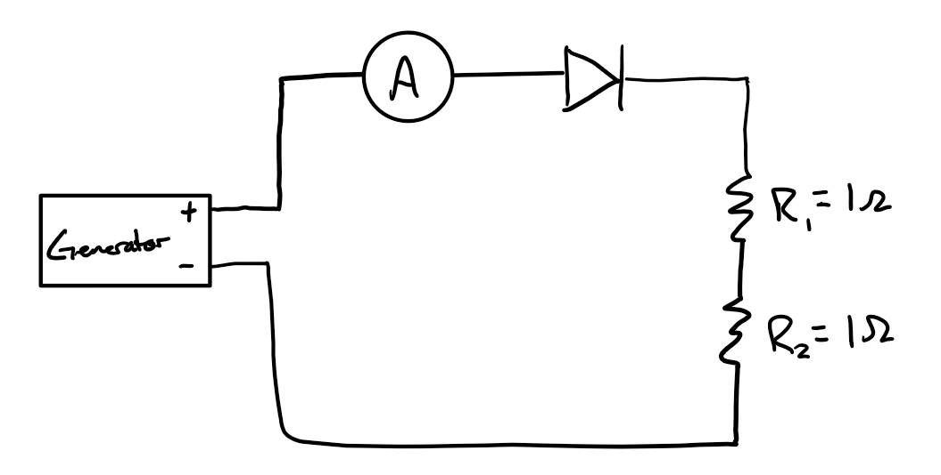

Justification:

Voltage was measured across the diode and it was consistently ~0.8V. We spun the turbine at a few different speeds and the variation was very small.

